**OUTREACH SCHOOLS EXAMINATION BOARD**

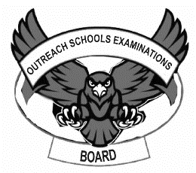 **BEGINNING OF TERM III EXAMINATION 2023**

**PRIMARY TWO**

**READING**

**My name is __________________________________________**

**I am in ______________________________________________**

**My school is _________________________________________**

1. **Listen and write.**

**Sound words**

a _____________ a. ______________

b_____________ b. ______________

c_____________ c________________

**sentences**

a.____________________________________________________________

b.____________________________________________________________

1. **Write these words in small letters.**

NAME ____________________ LORRY ___________________

WOMAN __________________ UMBRELLA _________________

EDUCATION __________________

1. **Fill in the correct answer.**
2. This stone is _____________heavy for me to carry.(two, to, too)
3. she is coming out of a ________________(hat, hut)
4. I_______________ nothing to his brother.(new, knew)
5. He is eating _________________(pork, fork)
6. Two things make one ___________.(pear, pair)
7. 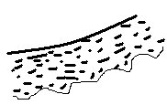**Write Yes, it is or No, it is not.**

Is this a pencil?

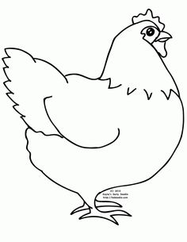 ___________________________________________

Is this a snake?

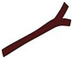 ____________________________________________

Is this a stick?

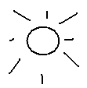 _____________________________________________

Is this a star?

_____________________________________________

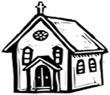 Is this a mosque?

______________________________________________

1. 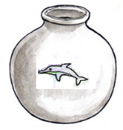**Make good sentences.**

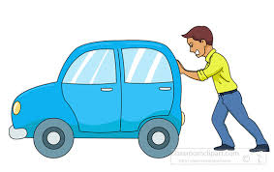 _______________________________________________

_______________________________________________

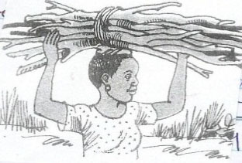

_______________________________________________

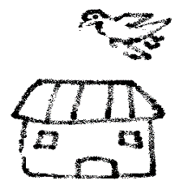

________________________________________________

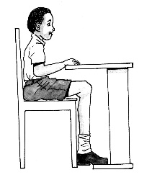

_______________________________________________

1. **Use “a” or an to fill the blanks.**
2. You can not kill____________ insect using ___________umbrella.
3. Our hen laid________________ egg in the kitchen.
4. My mother gave me ______________basket.
5. It is _______________axe which Tom used to cut a tree.
6. He went to _______________zoo and saw eagle.
7. **Fill in (caps ,people ,songs ,two ,cars, hands, goals)**

**FOOTBALL MATCH**

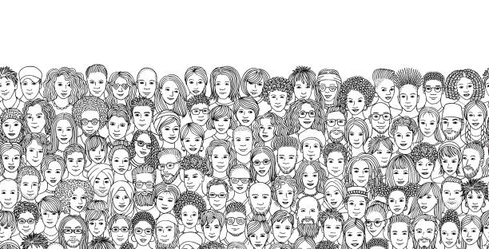Last Saturday ,there was a very interesting football match at Namboole. Many _________________went to

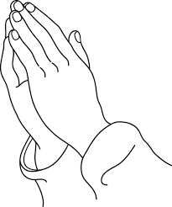Namboole. They were singing ____________________ .They shouted

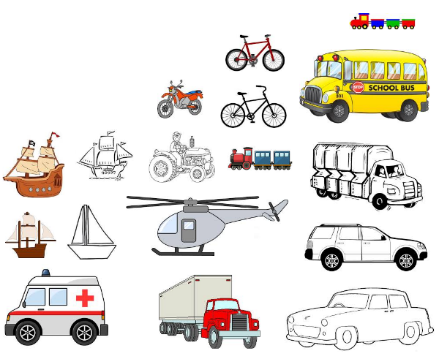and clapped their ____________________. Oh! Everyone was excited.

They stopped all the _________________. They were putting on 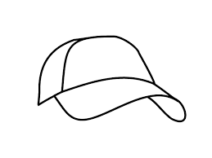 ___________.The football match was between Uganda and Kenya. Uganda scored ___________and Kenya scored only 1 goal.

1. **Copy and write.**

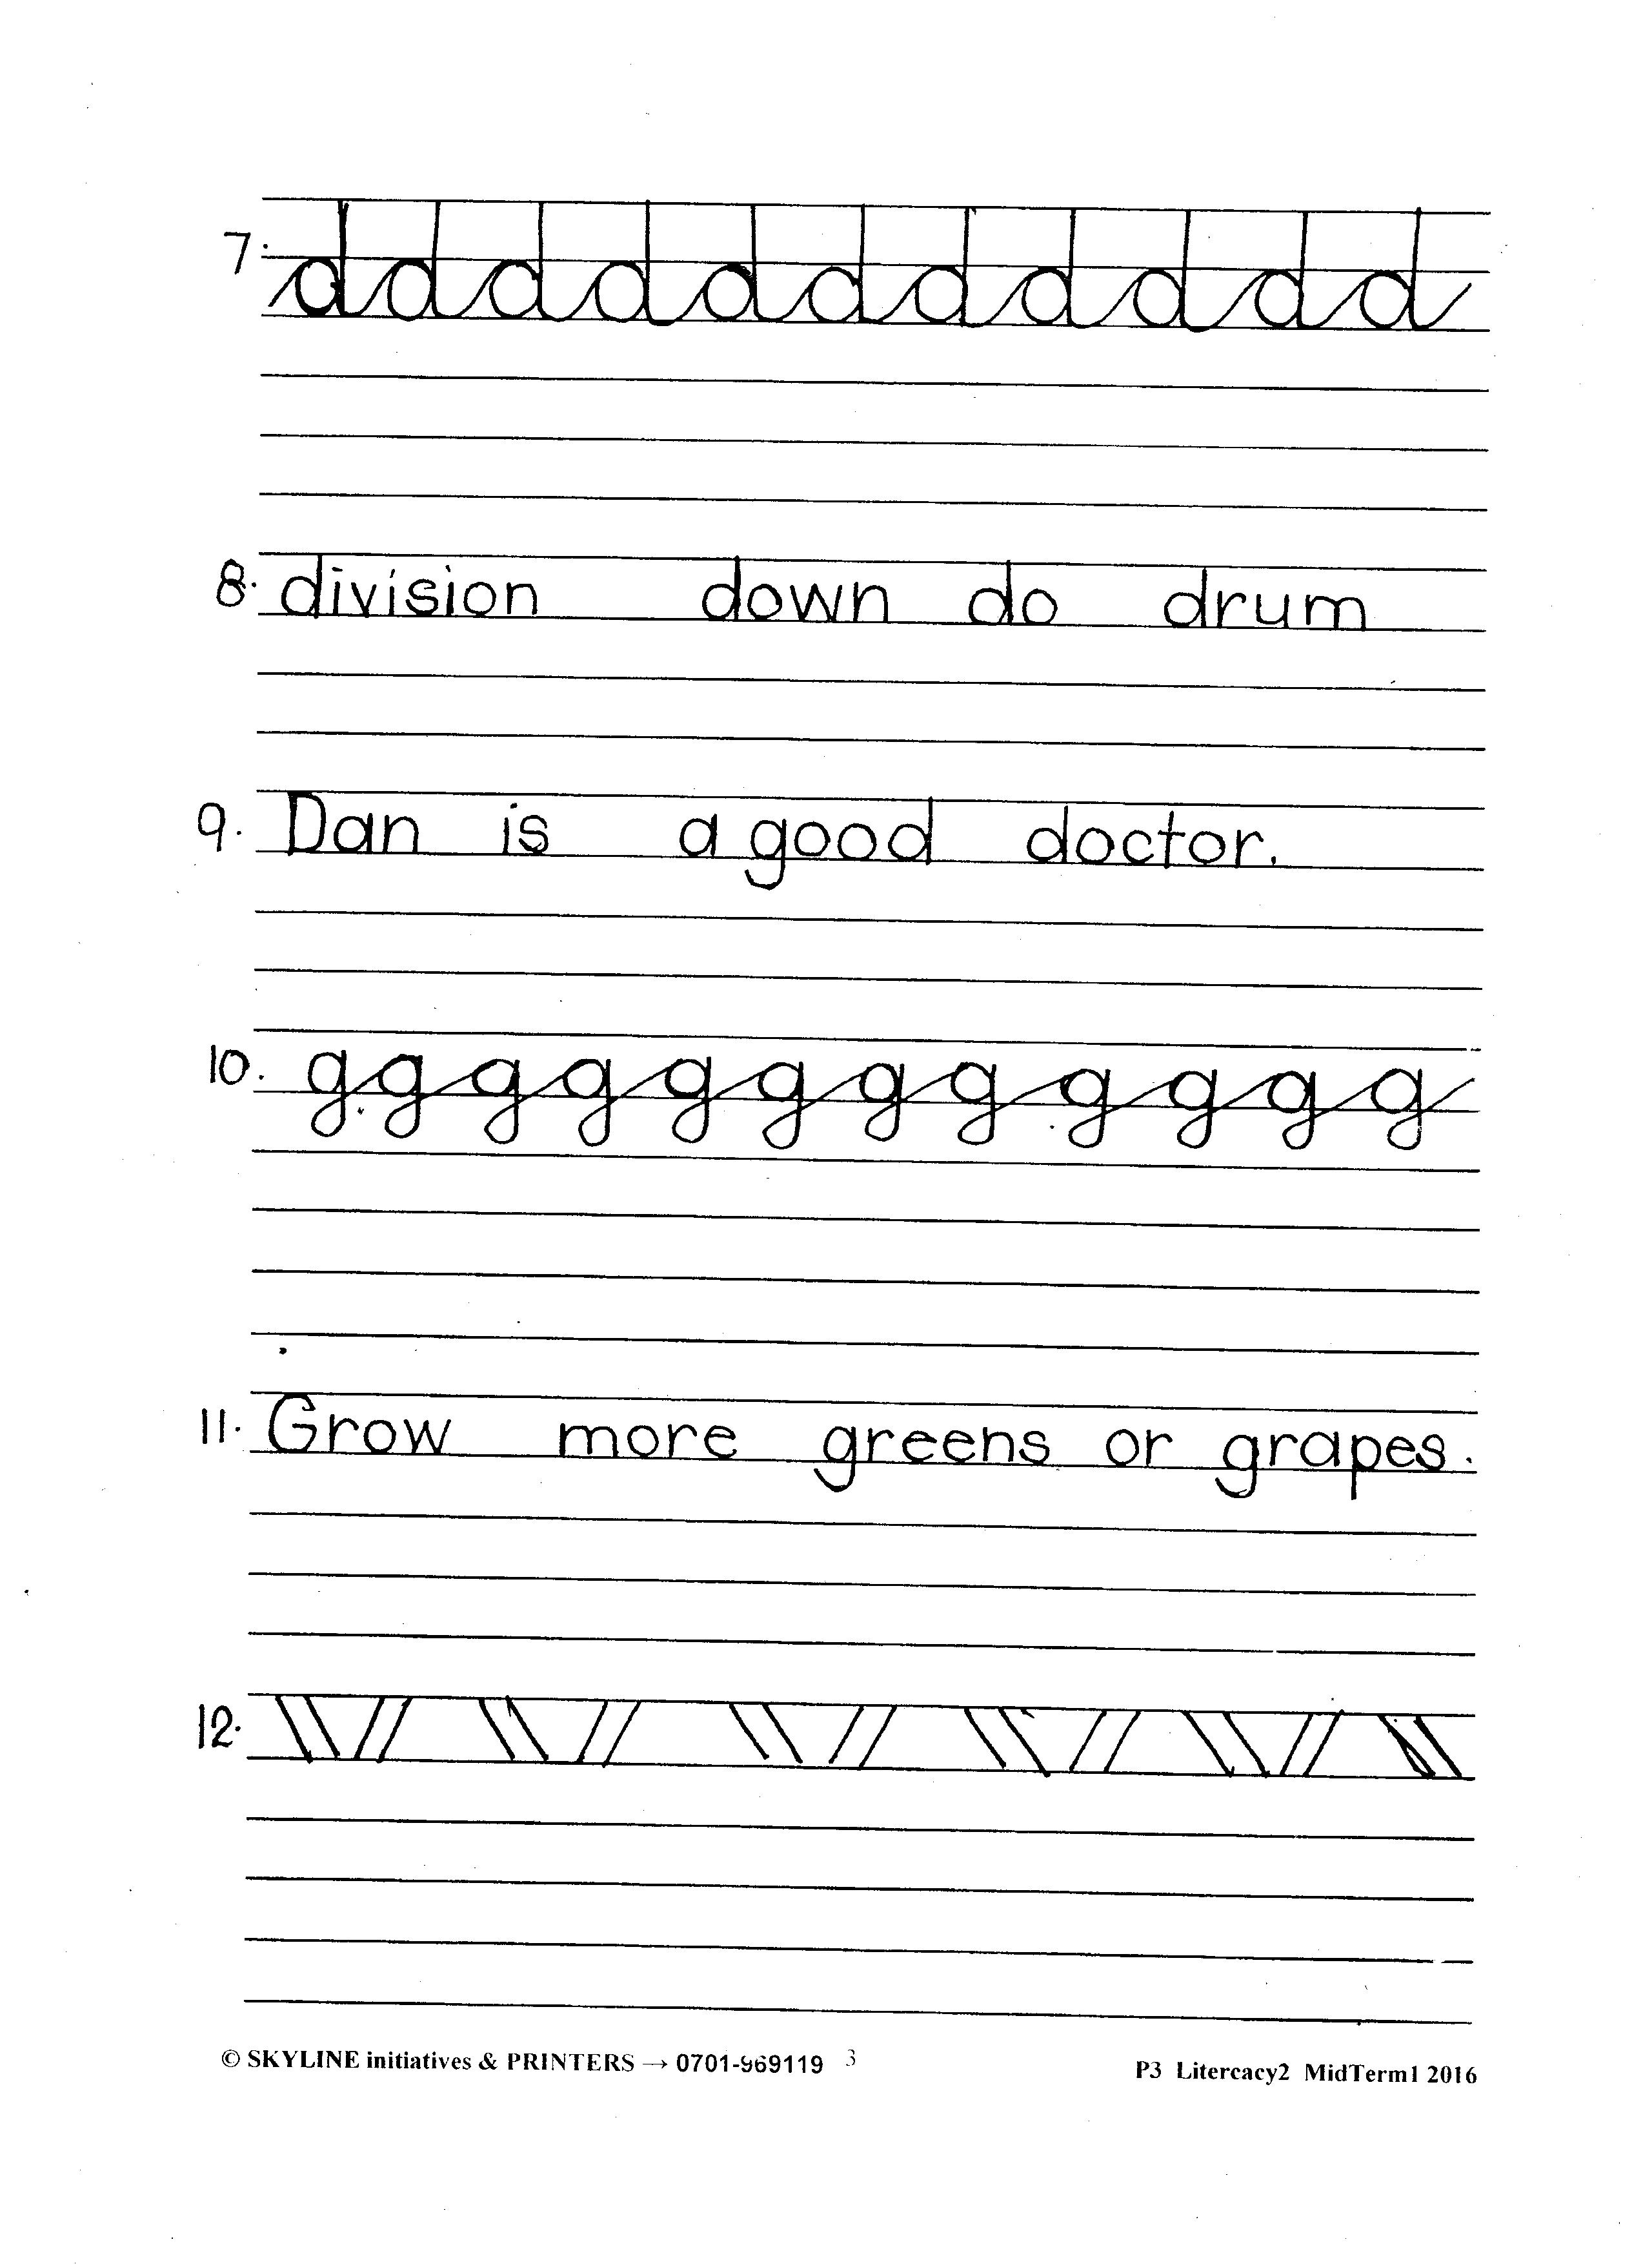

**END**